MIRAS MODEL UNITED NATIONS ALMATY 2019

The Fourth Industrial Revolution in Technology – new challenges for education

MIS MUN PROGRAMME 2019
21-22 February

Table of contents
Invitation..........................................................................................2
Why Model United Nations “MIS MUN 2019”?...............................................................................................2
- What students gain from participating in a MUN conference is listed below.......................................................................2
Committees and topics.....................................................................3
- Security Council (English Language)...............................3
  - Partnerships for sustainable peace
  - Cyber security measures to combat international terrorism
- Disarmament and International Security Council (English Language)............................................................4
  - Improving the use of technology in peacekeeping operations
  - Exploring peaceful development and implementation of drone technologies.
- Human Rights Committee (English Language).............5
  - Eliminating violence against children and youth
  - Redefining citizenship in the context of artificial intelligence
- Social and Cultural Committee (Russian Language)….5
  - Measures to advance educational and opportunity access for children with disabilities
  - Promoting IT coding literacy as an essential skill for the 21st Century
- Economic and Financial Committee (English Language)...........................................................................6
  - The role of information and communications technology in industrial development
  - Restructuring the education system for the economy of the future
- Environmental Committee (Kazakh Language)……….7
  - Ensuring access to affordable, reliable, sustainable, and modern energy for all
  - Harnessing technology to better confront the challenges of climate change

- World Health Organization (English Language)...........8
  - Artificial intelligence in medicine: future possibilities
  - Discussing the ethics of genetically modified embryos
- General Resources……………………..........…………....8
In Committee..................................................................................9
- Schedule
- Working paper and resolutions
- Press Corps
- Debate
Closing ceremony: reading the resolutions ................................10
Dress Code…………………......................................................................10
Excursion tours for guests and delegates of the conference......11
Contact Information.......................................................................13

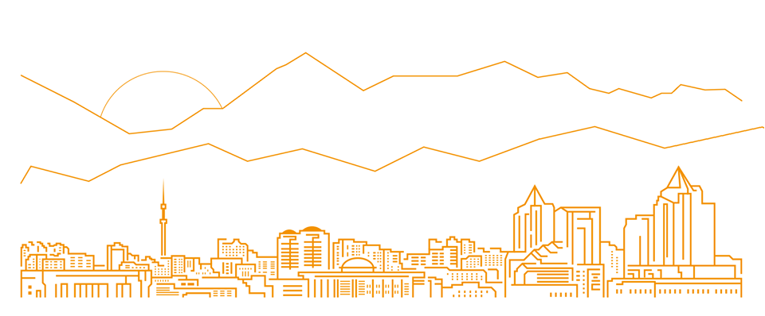

Welcome to Miras MUN Conference 2019!

Dear Teachers, Advisors and Students:

It is our distinct pleasure to cordially invite you to the annual Model United Nations Conference at Miras International School, which will be held from February 21st through February 22nd in Almaty.
Since its inception in 2004, MISMUN has offered its delegates an unrivaled Model United Nations experience by running highly-personalized, engaging and dynamic crisis committees. The conference is highly committed to academic and administrative excellence, offering a unique MUN experience to students not only from Kazakhstan, but from all over the world. It fosters problem-solving skills, and allows new students to gain a first taste of organized debate and provides veteran students the opportunity to hone their debating and public speaking skills.
MISMUN is more than a simulation of the United Nations. Through this conference we provide a unique opportunity to engage students in a professional, friendly and collaborative environment and develop their research, communication and leadership skills. This will in turn increase their experience and knowledge of broad-based world issues and concerns, and reinforce the message of personal responsibility in this world. The sessions will be held in three languages: English, Russian and Kazakh and students can choose from one of these. Both new and practiced participants will find it a rewarding experience.
We very much look forward to the most intellectually stimulating and enjoyable conference that we know MISMUN 2019 will be, and we hope that you do too. In the meantime, please refer to our website at http://mismun.miras.kz/en/ for a more detailed description of the conference as well as the committees.
We invite you to experience what MISMUN 2019 has to offer!

Why Model United Nations “MIS MUN 2019”?
MUN conference is a large-scale roleplay in which high school students “represent” diplomats of different countries and simulate the real UN committees.
During the conference its delegates discuss the world topical issues and try to resolve them, using joint efforts. Thus, it is aimed to attract school children’s attention to the present-day global problems, form a holistic picture of the world, develop inquiry skills and abilities to overcome conflicts, and maintain intercultural communication and collaboration.
What students gain from participating in a MUN conference is listed below.
Students will:
- learn new information about world politics
- improve information search skills
- defend their points of view using powerful arguments
- learn to speak in public
- improve their language skills
- develop their organizational skills
- learn to create official documents
- learn to work in a team and realize the significance of their contribution
- have a good time and meet new friends

Committees and Topics
- Security Council (English Language)
Under the UN Charter, the Security Council has primary responsibility for the maintenance of international peace and security. Under the Charter, all Member States are obligated to comply with Council decisions.
The Security Council takes the lead in determining the existence of a threat to the peace or act of aggression. It calls upon the parties to a dispute to settle it by peaceful means and recommends methods of adjustment or terms of settlement. In some cases, the Security Council can resort to imposing sanctions or even authorize the use of force to maintain or restore international peace and security.

- Partnerships for sustainable peace
In April 2016 the UN Security Council and General Assembly adopted resolutions which marked a fundamental shift in the UN’s understanding of peacebuilding by introducing the new concept of sustaining peace. In these resolutions, sustaining peace is seen as “a goal and process…aimed at preventing the outbreak, escalation, continuation and recurrence of conflict,” meaning that peacebuilding efforts are needed before, during and after conflict. It also called for a more comprehensive approach to peacebuilding.

- Cyber security measures to combat international terrorism
Terrorism has been on the international agenda since 1934. Among 18 universal conventions and protocols (14 instruments and 4 amendments) the UN Security Council adopted several conventions related to terrorism. The most important of them is UN Security Council Resolution No. 1373, adopted on 28 September 2001, a few weeks after 9/11 attacks in New York and Washington.
In September 2006 Member States of the UN embarked upon a new phase in their counter-terrorism efforts by agreeing on a global strategy to counter terrorism.

- Disarmament and International Security Council (English Language)
DISEC, or the disarmament and international security committee, is the First Commission of the General Assembly. This committee deals with disarmament, global challenges and threats to peace that affect the international community and seeks out solutions to the challenges in the international security regime.
- Improving the use of technology in peacekeeping operations
Innovation can be transformative in modern peacekeeping. In field technologies in particular—a strategically important area of the United Nations—applying novel approaches to global peace operations can help peacekeepers make faster and more informed decisions, better-protect civilians and uniformed personnel by keeping them connected, and improve the readiness of military communications officers prior to their deployment to a peacekeeping environment.
The Partnership for Technology in Peacekeeping initiative of the Department of Field Support (DFS) was established in 2014 by the Information and Communications Technology Division of DFS with an objective to bring greater involvement to peacekeeping through innovative approaches and technologies that have the potential to empower UN global operations.
- Exploring peaceful development and implementation of drone technologies
Drone technology, now inexpensive and accessible, is continuously evolving and being put to several novel uses around the world. Initially known for their military use, drones are now being used by individual entrepreneurs, SMEs, and large companies to accomplish various other tasks.
Drones are also used for maintaining the law. They help with the surveillance of large crowds and ensure public safety. They assist in monitoring criminal and illegal activities. In fact, fire investigations, smugglers of migrants, and illegal transportation of drugs via coastlines, are monitored by the border patrol with the help of drones.

- Human Rights Committee (English Language)
The Human Rights Committee is the body of independent experts that monitors implementation of the International Covenant on Civil and Political Rights by its State parties.
All States parties are obliged to submit regular reports to the Committee on how the rights are being implemented. States must report initially one year after acceding to the Covenant and then whenever the Committee requests (usually every four years). The Committee examines each report and addresses its concerns and recommendations to the State party in the form of "concluding observations”.

- Eliminating violence against children and youth
Violence against youth can take on a wide variety of forms and occur at a wide range of ages, though all are linked by the definition of interpersonal violence: “the intentional use of physical force or power, threatened or actual, against another person or against a group or community that results in or has a high likelihood of resulting in injury, death, psychological harm, maldevelopment, or deprivation.” This can include juvenile violence, bullying, youth dating violence, gang membership and child maltreatment.

- Redefining citizenship in the context of artificial intelligence
Artificial intelligence (AI) is an area of computer science that emphasizes the creation of intelligent machines that work and react like humans. Some of the activities computers with artificial intelligence are designed for include: speech recognition, learning, planning, and problem solving. In some countries digital public services will be soon powered by government data and artificial intelligence like chatbots and smart forms. The intelligent automation of programs helps make services more open, responsive, informative, and accessible for the people.

- Social and Cultural Committee (Russian Language)
The United Nations General Assembly Third Committee (also known as the Social, Cultural, and Humanitarian Committee or SOCHUM) is one of six main committees at the General Assembly of the United Nations which deals with matters concerning human rights and humanitarian affairs. The Third Committee also addresses the topics of the advancement of women, protection of children, indigenous issues, treatment of refugees, and promotion of fundamental freedoms.

- Measures to advance educational and opportunity access for children with disabilities
Children with disabilities face multiple forms of discrimination which leads to their exclusion from society and school. Attitudes toward children with disabilities, as well as a lack of resources to accommodate them, compound the challenges they face in accessing education. While lack of access to school is an issue, an equal concern is the inability of the education system to ensure quality education for children with disabilities.

- Promoting IT coding literacy as an essential skill for the 21st Century
IT literacy is different from digital literacy or informatics literacy / computer science literacy that puts more emphasis on computer programming, algorithms and other important mathematical and computational concepts. As the information technology (IT) has and will have a huge role and impact on the future and existing style of learning and teaching, it is important for every student to acquire computer skills and be literate in IT. IT literacy is the key to today's empowerment and education is the best foundation for it.

- Economic and Financial Committee (English Language)
The United Nations General Assembly Second Committee (also known as the Economic and Financial Committee or ECOFIN) is one of the six main standing committees of the United Nations General Assembly. The Second Committee is responsible for examining problems in the area of global finances and economics.

- The role of information and communications technology in industrial development
ICT development includes many types of infrastructure and services, ranging from telecommunications, such as voice, data, and media services, to specific applications, such as banking, education, or health, to the implementation of electronic government (e-government). Each of these types has its own trends that vary across countries and regions. Industry is considered to be the most vital sector for ICT intervention as it is considered as the primary economic sector and produces the most basic of human needs.

- Restructuring the education system for the economy of the future
Trying to define school education of the future is both popular and difficult. One approach can be to think about changing learning environments, including the use of digital tools. Another is to consider teaching and learning of a range of competences. A wave of new technology has been introduced into schools up and down the country changing the way teachers deliver lessons and how students learn. Classrooms, it is predicted, will join the Internet of Things – a network of devices like smartwatches that connect and share data with other items and systems – and create ‘smart schools’ where the teachers, students and devices become more connected.

- Environmental Committee (Kazakh Language)
The Committee on Environment and Development addresses the following issues:
- Policies and strategies for enhancing environmental sustainability of economic and social development, including climate change mitigation and adaptation;
- Policies and strategies for sustainable management of natural resources including water; and
- Policies and strategies for promoting inclusive and sustainable urban development.

- Ensuring access to affordable, reliable, sustainable, and modern energy for all
Energy is a critical enabler. Every advanced economy has required secure access to modern sources of energy to underpin its development and growing prosperity. In developing countries, access to affordable and reliable energy services is fundamental to reducing poverty and improving health, increasing productivity, enhancing competitiveness and promoting economic growth. This is because it is essential for the provision of clean water, sanitation and healthcare, and provides great benefits to development through the provision of reliable and efficient lighting, heating, cooking, mechanical power, transport and telecommunication services.

- Harnessing technology to better confront the challenges of climate change
The climate system is highly complex, as are the human institutions that are affected by and that must respond to climate change. The difficulty of developing sound strategies for responding to climate change, and of building public support for such strategies, stems in part from the inherent complexity of the issue. Some of this complexity relates to the physical science of climate change; but understanding and responding to climate change also raises many social, economic, ethical, and political challenges.

- World Health Organization (English Language)
WHO works closely with the United Nations system to support its Member States in achieving their national priorities and ensuring better health outcomes. WHO strives to increase coherence, effectiveness and efficiency in delivering results.
WHO collaborates with the UN system to position health in the debates and decisions of UN intergovernmental bodies; contribute to a coherent and effective UN system at global, regional and country levels; provide leadership in health-related humanitarian efforts, including as the Health Cluster Lead; and promote alliances and interagency approaches to address health issues.

- Artificial intelligence in medicine: future possibilities
Artificial intelligence (AI) is an area of computer science that emphasizes the creation of intelligent machines that work and react like humans. Some of the activities computers with artificial intelligence are designed for include: speech recognition, learning, planning, and problem solving. Artificial intelligence (AI) research within medicine is growing rapidly. AI in healthcare is the use of algorithms and software to approximate human cognition in the analysis of complex medical data. Specifically, AI is the ability for computer algorithms to approximate conclusions without direct human input.

- Discussing the ethics of genetically modified embryos
The prospect of modifying genes in human embryos has long been controversial though. Gene editing could disrupt healthy genes when it is meant only to fix faulty ones. A widespread global agreement is that heritable genetic modification should remain off-limits, a commitment that has reflected in the laws of many nations, a binding European treaty, several international declarations, and numerous public opinion surveys. Besides that gene editing could disrupt healthy genes when it is meant only to fix faulty ones.

- General Resources
The resources listed below are only a starting point for your research. We highly recommend extensive use of academic books; scholarly journals; newspaper articles; and information from websites of UN bodies, affiliated non-governmental organizations (NGOs), and other international or regional organizations such as the World Bank, WHO, OECD, APEC, etc. Delegates are advised to evaluate online sources carefully and only use reputable sources.
- NMUN Rules of Procedure
- NMUN Delegate Preparation Guide
- Committees and Topics
- United Nations Website
- United Nations Handbook
- The PGA Handbook: A practical guide to the United Nations General Assembly

- UN Bibliographic Information System
- UN Global Issues Overview
- UN Research Guides and Resources
- CIA World Factbook
- NMUN Conduct Expectations
- Position Papers

In Committee:
Schedule:
Model United Nations MIS MUN 2019 Almaty holds seven committee sessions over the two days of conference. Committee Chairs and Co-Chairs guide the progression of debate over the course of these sessions while enforcing and educating delegates about formal rules of parliamentary procedure. Although not a required outcome of conference, delegates are challenged to reach a consensus in their committee, often in the form of resolutions or other written document, while accurately representing their countries’ policies.
Working paper and resolutions:
Working paper are used to collect and circulate delegate ideas about a topic. These ideas are debated and eventually developed into formal documents written in the style of actual UN resolution. These resolution represent hours of debate, negotiation, and compromise and may eventually be adopted as the formal recommendation of a committee following strict voting procedure. In additions, to maximize the incentive for compromise, only one resolutions can be passed for each topic.
Press Corps
Another opportunity for non-traditional representation, Press Corps gives a select group of delegates the opportunity to represent various real world news sources. These reports and journalists will be in the charge of capturing important moments MUN MIS MUN Conference, whether trough an article critiquing a resolution, a political video about a controversial issue, an interview with the

popular Chair, or photos of committees in session. Press Corps publications will be posted on a conference blog, making Press Corps delegates the voice of conference.

Debate
Debate is at heart of every MIS MUN Conference. Whether during un-moderated caucuses or lunch-time meetings or contained in written notes, debate provides a means for sharing and disputing viewpoints, establishing dialogue, and reaching a consensus. MIS MUN Conference is a forum for new ideas and creative solutions. Delegates should come prepared to engage in lively debate while respecting themselves, their peers.

Closing ceremony: reading the resolutions
The delegates of the committees will present their resolution.
Representatives of the coordination Council will give Certificates to participants and delegates of the UN Model MIS MUN 2019 conference. Photo session.

Dinner
Free friendly communication. Delegates will be able to present their committees in a team presentation. Participants will be invited to leave feedback on the conference, exchange experiences, and participate in a photoshoot.

Dress Code
Model United Nations is a formal event therefore there is a strict dress code that has to be followed by every delegate. When selecting your outfit think that your clothes and the way you look will be the first impression people have on you, so to be taken seriously you should dress up serious and follow Model United Nation’s dress code. All clothing must be conservative and appropriate, neutral solid colors are preferred, though light colors are also acceptable. No denim or “jeans” material of any kind.
The key words for your attires are “Business”, “Formal” or “Professional”.

- Male delegates are expected to wear long-sleeve shirts, a tie,
jacket, trousers, and dress shoes.
- Female delegates are expected to wear a dress (knee-length)
or trousers/skirt (knee-length) with a dress shirt. Delegates should wear business-appropriate dress shoes.
Remember that Model United Nations is a simulation of diplomacy. Diplomacy goes far beyond actual words spoken at a formal session. It is more than negotiating at an unmoderated caucus. Everything a delegate says and does indicates a meaning. Their body language matters and so does their dress.

Excursion tours for guests and delegates of the conference
Day 1
21 of February, 2019 (Thursday) - The Kok Tobe Park

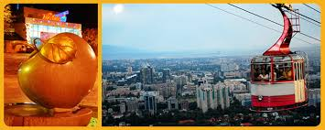

Tourists go to the Kok Tobe Park for a ride on a cable car and observation decks to enjoy the panoramic views of Almaty and Zailiyskiy Alatau ridge. Special binoculars installed on the sites will help you see the beauty of the surroundings. You can have a look of the city from an even higher height if you decide to ride on the Ferris wheel, whose height is 30 meters (1136 meters above sea level). One of the Central attractions of the Park is the fountain of desires "Alma" made in the form of a huge granite Apple — the symbol of Almaty. In the bowl of the fountain visitors throw coins for good luck and wealth hoping that their wishes will come true. The second most photographed sculpture — monument to the Beatles was installed in 2007.

High – mountain “Medeo” skating rink

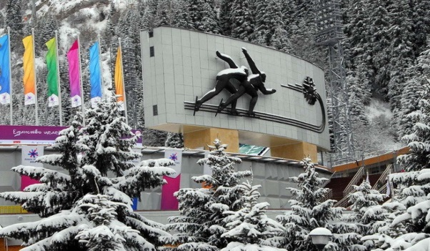

Medeu is a high-mountain sports complex located in the high-mountain tract of Medeu at an elevation of 1691 meters above sea level just below the mountain resort "Shymbulak". Medeu is the world's largest Alpine complex for winter sports with the largest area of an artificial ice rink — 10.5 thousand m2. The high mountains and the pure mountain water which turns into ice instantly contribute to achieving high results in speed skating; over
200 world records have been set for all distances among men and women. Almaty skating rink was nicknamed "factory of records". It is a symbol of urban planning and architecture of National importance.

Day 3
23 of February, 2019 (Saturday)
The program of the tour of Almaty (optional)
2-3 hours
Central streets of the city, 28 Panfilovs Park, Museum of folk musical instruments, the Republican Square, Astana square, the Independence monument, etc.
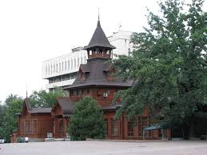
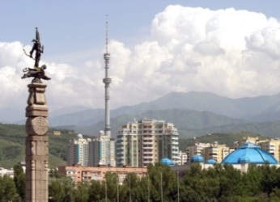
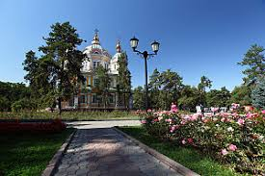

Big Almaty Lake
8 hours
Walking tour around the lake
As an option - a visit to the complex, “Sunkar,” the falconry show.
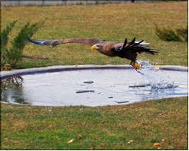

A field trip to Big Almaty Lake is interesting at any season. Its length is 1.5 km, the depth is 35 m. Above the lake is the Tien-Shan Astronomical Observatory (2,700 m) and the Space Station (3,300 m), where you can stay overnight to observe celestial bodies.
Even in winter, when the lake’s water surface is covered with ice and snow, it admires with its space and mystery.
The road to the lake is very picturesque and beautiful. It passes by slim spruces and mixed forests. In summer everyone is enamored of their fresh greenery and in autumn of their vivid colors! The serpentine of the road sometimes runs under the crowns of the trees, sometimes sweeps along a steep slope above the gorge.
On the way, tourists are given general information about the Zailiysky Alatau, the Big Almaty river and the gorge itself. You will see the severe beauty of the mountains, get acquainted with the flora and fauna and know the history of the discovery and development of this area, its present and future. You will examine the space communications station, “Orbita,” visit the unique mud dam, which protects the western part of the city from catastrophic mud-and-stone flows, and the cascade of the hydro-electric power station.
A wonderful field trip to one of the Kazakhstani unique farms, breeding predatory birds that inhabit the territory of Asia. Here you can see the golden eagle, the falcon and many other birds of prey in the wild. The farm is not far from a waterfall in the gorge, “Ayu-Sai.”
This outing will allow you to forget your everyday problems and to melt into the nature.

Venue: Miras International School – Branch of Nursultan Nazarbayev Educational Foundation 190 Al-Farabi Avenue, Almaty, Kazakhstan

Date: 21st - 22nd February, 2019

Sightseeing: 23rd February, 2019

Fee: 18 000 KZT per student (participant pack; transportation; breakfast, lunch and a gala)
A detailed schedule of the sessions, opening and closing ceremonies, committees and topics as well as the code of conduct will be send later. In addition, we encourage you to go to our webpage http://mismun.miras.kz/en/ to keep up with our conference updates; there we will continuously update all information you need including case studies and study guides.

If you have any questions, don’t hesitate to contact:

Mr. James Lothschutz, Secondary School Principal
SSPrincipal@almaty.miras.kz

Mrs. Yelena Nenasheva – MISMUN2018 Coordinator
e_nenasheva@almaty.miras.kz
+7 (701) 617 33 32

Mrs. Lina Nikolova – MISMUN2019 Co-Coordinator at E-mail: l_nikolova@almaty.miras.kz

We are looking forward to welcoming you at MISMUN 2019 in Almaty as one of this year´s delegation!

Yours sincerely,
MIRAS MUN Team

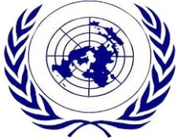

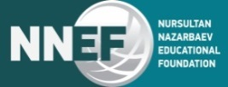

http://mismun.miras.kz

