recommended hotels in almaty

Rahat Palace Hotel
29/6 K. Satpayev St, Almaty, Kazakhstan  Rahat Palace Hotel is a harmonious combination of eastern luxury, European elegance, art of welcoming guests, hedging them with care and attention. Hospitality is a tradition which remains unchanged and is being enshrined by the Hotel.  Rahat Palace Hotel in Kazakhstan is situated between the Alatau Mountains and the plains, with most hotel rooms offering spectacular mountain views. The hotel is conveniently located in Almaty city centre and easily accessible from Almaty International Airport. The Rahat Palace Hotel hosts a health club with a spectacular temperature controlled indoor leisure pool, the perfect retreat for your vacation in Almaty, Kazakhstan. | 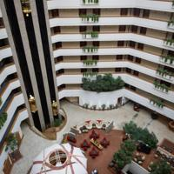
Room types | Standard price | Corporate price
King Room | KZT 56,000 | KZT 28,000
Twin Room | KZT 62,000 | KZT 34,000
King Deluxe | KZT 64,000 | KZT 36,000
Junior Suite | KZT 86,000 | KZT 58,000
Executive Suite | KZT 96,000 | KZT 68,000
Presidential Suite | KZT 220,000 | KZT 220,000

All rates subject to 12 % VAT.
All prices includes breakfast, WiFi Internet (64 kBit/sec) and SPA use (Swimming pool, sauna, gym).

Check-in time is 15:00
Check-out time is 12:00

HOLIDAY INN ALMATY

4-star hotel
2D Timiryazev St., 050013, Almaty, Kazakhstan  The modern, glass-fronted Holiday Inn Almaty overlooks the scenic Tien Shan Mountains from its city centre location, which is ideal both for business and leisure travelers. You'll find our welcoming hotel in the heart of Almaty's prestigious financial district and steps from Republic Square and other major sights. The Nurly Tau Business Centre with companies like Deloitte, PwC and AIG Insurance is a 10-minute walk away. | 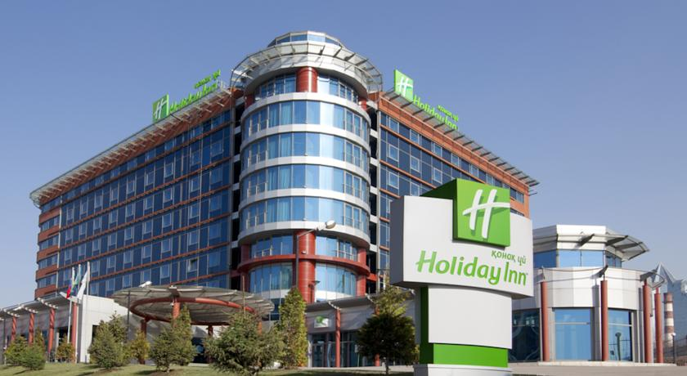
Cost per two nights
№ | Rooms | KZT | Note
1. | Standard | 52775 | per 2 nights upon advanced payment
2. | Executive | 63671 | per 2 nights upon advanced payment

Kazakhstan hotel
52 Dostyk St.  Kazakhstan Hotel is a unique historical monument of Almaty City. Kazakhstan is a hotel in Almaty which was being built between 1975 and 1977. The building has been recognized as a landmarked building and in 1979 was given the status of a building of the Republican significance. It has 26 floors and is 102 meters high. | 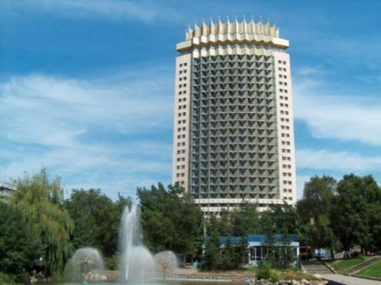
Cost per two night

№ | Rooms | single | double
 |  | KZT | KZT
1 | Standard | 20 000 | 25 000
2 | Superior | 25 000 | 30 000
3 | Junior Suite | 30 000 | 35 000
4 | Queen Suite | 40 000 | 40 000
5 | King Suite | 57 000 | 57 000

DOSTYK HOTEL
S. Kurmangazy St., the corner of D. Kunayev St.  Dostyk Five Start Hotel is located in the downtown and cultural center of Almaty. Its building is created in the style of a palace and creates elusive atmosphere of exclusiveness. It was reopened in late 2008 after a major reconstruction. The hotel has been recognized as a 5 star hotel and has 72 comfortable rooms of different type, SPA center and a swimming pool, VIP sauna (Turkish and Finnish), modern business center and conference rooms designed for 80 and 200 people. There are latest technologies in the hotel. | 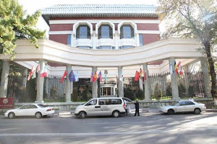
Cost per night

Below we are honored to offer special rates for accommodation
for MIRAS International School at the “Dostyk” hotel.

Room type | Rack Rate | Special Rate
Standard | 50400 KZT | 33600 KZT
Superior | 56000 KZT | 35280 KZT
Deluxe | 61600 KZT | 39200 KZT
Executive Suite | 78400 KZT | 54880 KZT
Presidential Suite | 224000 KZT | 156800 KZT
Additional Accommodation: 5600 KZT

In our hotel, located near central streets of the city, in so-called “Gold Square”, covering the most important business, cultural and administrative centers, we are honored to present you 72 cozy, modern, high technically equipped rooms (system of interactive TV, microclimate, mini-bar, mini-safe, high-speed Internet access).

Standard room: Total room area 21 m². One bed in the room, size 140 х 200 sm, shower cabin, bidet, hairdryer, LED TV, mini safe box, minibar.
Superior (Twin): Total room area 27 m². Two separate beds in the room, size 110 х 200 sm, shower cabin, bath, bidet, hairdryer, LED TV, mini safe box, minibar.
Deluxe: Total room area 31 m². One big bed in the room, size 180 х 200 sm, shower cabin, bath, bidet, hairdryer, LED TV, mini safe box, minibar.
Executive Suite: Total room area 53 m². Two rooms, one big bed in bedroom, size 200 х 200 sm, shower cabin, bath, bidet, hairdryer, LED TV, mini safe box, minibar.
Presidential Suite: Total room area 158 m². Three rooms, one big bed in bedroom, size 200 х 200 sm, shower cabin, Jacuzzi, bidet, sauna, hairdryer, LED TV, mini safe box, minibar.

Room Rate including:

- Open Buffet Breakfast in the main Restaurant (7 a.m. – 10:00 a.m.)
- SPA center facilities
(Minors (children under 16) are not allowed at the gym. Minors under 16 are not allowed at the pool without parents).
- Free access to WiFi Internet

In addition we are ready to offer You:
- Conference rooms and meeting facilities from 10 to 200 pax with state of art technical equipment
- Meeting rooms available from 10 to 18 people
- Business Centre facilities
- Main Restaurant with European & Traditional Cuisine
- Transportation
- Translation services
- VISA Support and registration
- SPA Center treatments
- 24 hours internet Access

Ritz Carlton Hotel | 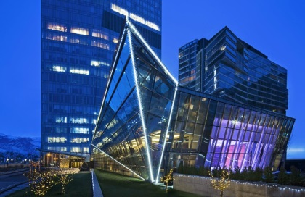

Categories of the rooms and the rates (21 – 24 February):

Deluxe room (without breakfast): 21/02 – 22/02 – 93,000 KZT plus 12 % TAX (single); 93,000 KZT plus 12 % TAX (double)
21/02 – 23/02 – 91,000 KZT plus 12 % TAX (single); 91,000 KZT plus 12 % TAX (double)
21/02 – 24/02 - 92,000 KZT plus 12 % TAX (single); 92,000 KZT plus 12 % TAX (double)

Deluxe Room (with breakfast): 21/02– 22/02 – 102,500 KZT plus 12 % TAX (single); 112,000 KZT plus 12 % TAX (double)
21/02 – 23/02 – 100,500 KZT plus 12 % TAX (single); 110,000 KZT plus 12 % TAX (double)
21/02 – 24/02 - 101,500 KZT plus 12 % TAX (single); 111,000 KZT plus 12 % TAX (double)

Club Room (with a club access): 21/02 – 22/02 – 110,000 KZT plus 12 % TAX (single); 125,000 KZT plus 12 % TAX (double)
2102 – 23/02 – 108,000 KZT plus 12 % TAX (single); 123,000 KZT plus 12 % TAX (double)
21/02 – 24/02 - 109,000 KZT plus 12 % TAX (single); 124,000 KZT plus 12 % TAX (double)

Corner Room (without breakfast): 21/02 – 22/02 – 107,000 KZT plus 12 % TAX (single); 107,000 KZT plus 12 % TAX (double)
22/02 – 23/02 – 105,000 KZT plus 12 % TAX (single); 105,000 KZT plus 12 % TAX (double)
23/02 – 24/02 - 106,000 KZT plus 12 % TAX (single); 106,000 KZT plus 12 % TAX (double)

Corner Room (with breakfast): 21/02 – 22/02 – 116,500 KZT plus 12 % TAX (single); 126,000 KZT plus 12 % TAX (double)
22/02 – 23/02 – 114,500 KZT plus 12 % TAX (single); 124,000 KZT plus 12 % TAX (double)
23/02 – 24/02 - 115,500 KZT plus 12 % TAX (single); 125,000 KZT plus 12 % TAX (double)

Executive Suite (without breakfast): 21/02 – 22/02 – 153,000 KZT plus 12 % TAX (single); 153,000 KZT plus 12 % TAX (double)
22/02 – 23/02 – 151,000 KZT plus 12 % TAX (single); 151,000 KZT plus 12 % TAX (double)
23/01 – 24/01 - 152,000 KZT plus 12 % TAX (single); 152,000 KZT plus 12 % TAX (double)

Executive Suite (with breakfast): 21/02 – 22/02 – 161,500 KZT plus 12 % TAX (single); 170,000 KZT plus 12 % TAX (double)
22/02 – 23/02 – 159,500 KZT plus 12 % TAX (single); 168,000 KZT plus 12 % TAX (double)
23/02 – 24/02 - 160,500 KZT plus 12 % TAX (single); 169,000 KZT plus 12 % TAX (double)

Club Suite (with a club access): 21/02 – 22/02 – 280,000 KZT plus 12 % TAX (single); 300,000 KZT plus 12 % TAX (double)
22/02 – 23/02 – 280,000 KZT plus 12 % TAX (single); 300,000 KZT plus 12 % TAX (double)
23/02 – 24/02 - 280,000 KZT plus 12 % TAX (single); 300,000 KZT plus 12 % TAX (double)

Additional information:

Check in time is 15:00 pm, and check out is 12:00 noon time.

Maximum persons in the room are 3 adults (third person charge applied).

Extra bed charge is 10,000 KZT per night, subject to advanced request and upon availability with maximum one bed in the room.

Early check-in is paid additionally:
1) if the guest arrives in the room before 08:00 in the morning, the early check-in is paid in the amount of 100% of the room cost.

2) if the guest arrives in the room after 08:00 in the morning, the early check-in is paid in the amount of 50% of the room cost.

Late arrivals are paid additionally:
1) if the guest leaves the room earlier than 18:00 pm, late check-out is paid in the amount of 50% of the room cost

2) if the guest leaves the room later than 18:00 pm, late check-out is paid in the amount of 100% of the room cost

USD to Tenge exchange rate - 1USD – 383 KZT (04 February , 2019)
1RR | = | 5.28 KZT
RR | = | 5.28 KZT

