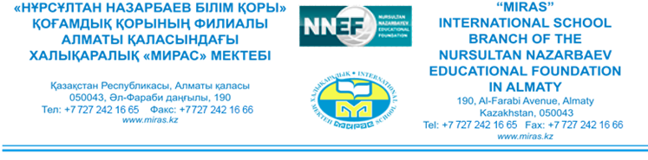
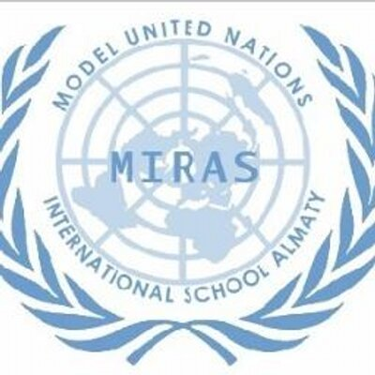

Welcome to MIRAS MUN Conference 2018!

Dear Colleagues:

You are cordially invited to participate in the annual Model United Nations Conference hosted by Miras International School of Almaty.

MISMUN is a three-day conference that will be held from Thursday, February 22nd to Saturday, February 24th, 2018. We welcome students and advisors from across the world to partake in an exciting and enlightening experience. Our conference fosters problem-solving skills, and allows new students to gain a first taste of organized debate and provides veteran students the opportunity to hone their debating and public speaking skills. MISMUN is also a great first conference for Model United Nations teams that are entirely new to your school.

We are pleased to inform you of the wide selection of committees that we will be offering again this year. In addition to the Human Rights Council and the Security Council, we will be running also specialized committees such as the Environmental Committee and Economic and Social Committee as well as a number of agency simulations that are not officially part of the United Nations but still play a significant role in global politics such as the World Health Organization. The working languages of the conference will be English, Russian and Kazakh which will give all participants a great opportunity to communicate in a language different from their own thus appreciating the significance of the use of foreign languages as a medium of communication. The MISMUN 2018 will also encourage all delegates to extensively research and analyze their respective country’s policies and political relations. We are confident that each of our committees will allow both novice and experienced debaters to put their skills to good use in an accurate simulation of 21st century international politics.

MISMUN is more than a simulation of the United Nations. Our event provides students with their first taste of organized discussion, allowing them to develop skills in diplomacy and debate while also acquiring knowledge of international relations. The delegates will conclude the conference having learned more about themselves and their own capabilities as well as having met with others whose perspectives may be different from their own. This is what we covet: the ability to open up the eyes of young people to ideas and solutions previously unconsidered.

We invite you to experience what MISMUN 2018 has to offer!

MISMUN Conference information:

Participants: all students of Grade 9-12
teachers and/or advisers helping in students’ preparation

Venue: Miras International School – Branch of Nursultan Nazarbayev Educational Foundation
190 Al-Farabi Avenue, Almaty, Kazakhstan

Date: 22nd – 24th February, 20118 (22nd and 23rd – conference, 24th – sightseeing and trips)

Sessions: 9:00h – 15:00h (lunch break – 1 hour)

Fee: 18 000 KZT (participant pack; transportation and trips; breakfast, lunch and a gala)

Deadline pre-registration: 15th December, 2017
Deadline final registration: 1st February, 2018

If you have any questions, don’t hesitate to contact:
Mrs. Yelena Nenasheva – MISMUN2018 Coordinator
E-mail: e_nenasheva@almaty.miras.kz

We are looking forward to welcoming you at MISMUN 2018 in Almaty as one of this year´s delegation!

Yours sincerely,
MIRAS MUN Team

